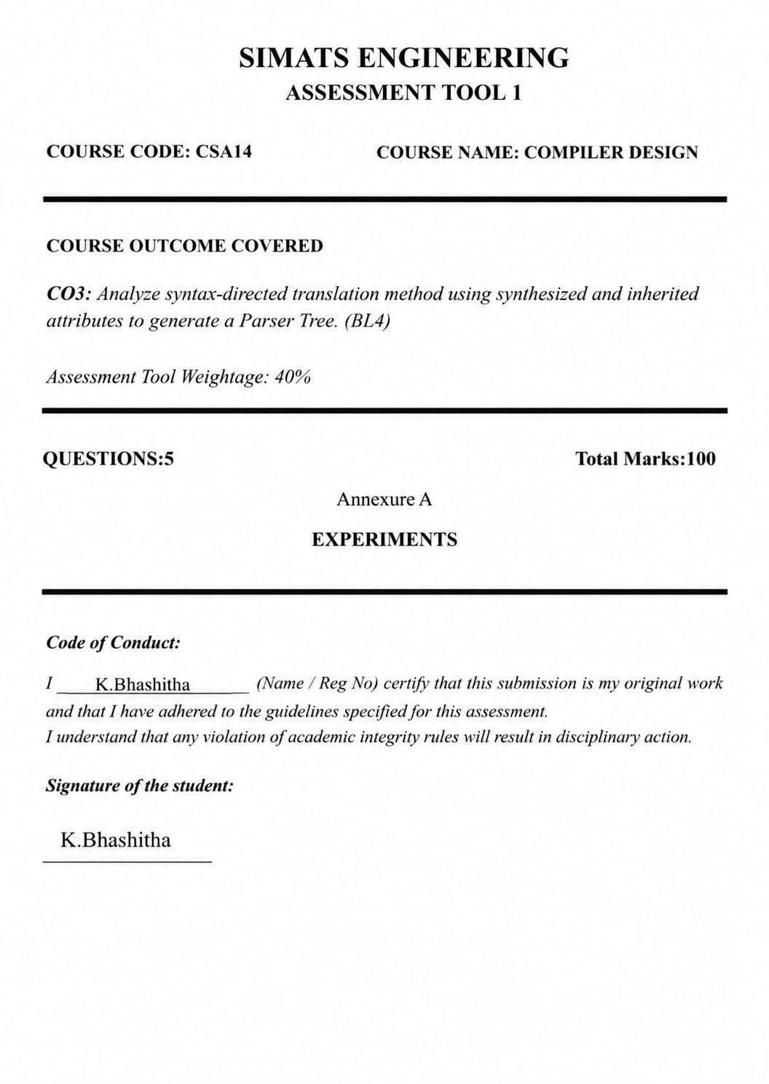
QUESTION 1
ANSWER:
Experiment 1: Syntax Directed Definition (SDD) for Expression Evaluation:

Aim

To design and implement a compiler-based desk calculator that evaluates arithmetic expressions using Syntax Directed Definitions (SDD) and synthesized attributes while maintaining operator precedence and associativity.

Objective:

• To understand Syntax Directed Definitions.
• To evaluate arithmetic expressions using semantic rules.
• To apply synthesized attributes for expression evaluation.
• To perform calculations according to operator precedence.
• To reduce unnecessary temporary computations.

Theory:

Syntax Directed Definitions (SDDs) are context-free grammar productions augmented with semantic rules. These semantic rules define how attributes associated with grammar symbols are computed. SDDs provide a systematic method for performing semantic analysis during parsing and are widely used in compiler construction.
In compiler design, SDDs are used for various purposes such as expression evaluation, type checking, intermediate code generation, symbol table management, and syntax tree construction. The semantic rules attached to grammar productions specify how the meaning of language constructs can be derived from their components.
An S-attributed definition is a special form of SDD in which all attributes are synthesized attributes. A synthesized attribute is computed using the attributes of child nodes and then passed upward to the parent node in the parse tree. Since all information flows from leaves toward the root, S-attributed definitions are naturally suited for bottom-up parsing techniques such as LR parsing.
The grammar used for arithmetic expression evaluation is designed to enforce operator precedence automatically. Multiplication and division operations are evaluated before addition and subtraction operations. Parentheses are used to alter the normal precedence rules and force specific evaluation orders.

Grammar with Semantic Rules:

E → E + T {E.val = E1.val + T.val}
E → E - T {E.val = E1.val - T.val}
E → T {E.val = T.val }
T → T * F {T.val = T1.val * F.val }
T → T / F {T.val = T1.val / F.val }
T → F {T.val = F.val}
F → (E) F.val = E.val}
F → digit {F.val = digit}

Explanation of Grammar:

• E (Expression) represents addition and subtraction operations.
• T (Term) represents multiplication and division operations.
• F (Factor) represents operands or parenthesized expressions.
• The attribute val stores the computed value of each non-terminal.
• The semantic rules calculate values during parsing.
This grammar naturally enforces operator precedence because multiplication and division are handled at the T level, while addition and subtraction are handled at the E level.

Example Evaluation:

Consider the arithmetic expression:
3 + 4 * 2
Step-by-Step Attribute Computation
Step 1: Evaluate First Operand
F → digit
F.val = 3
Step 2: Convert Factor to Term
T → F
T.val = 3
Step 3: Convert Term to Expression
E → T
E.val = 3
Step 4: Evaluate Second Operand
F → digit
F.val = 4
Step 5: Evaluate Third Operand
F → digit
F.val = 2
Step 6: Perform Multiplication
T → T * F
T.val = 4 * 2
T.val = 8
Step 7: Perform Addition
E → E + T
E.val = 3 + 8
E.val = 11

Final Result:

E.val = 11
Parse Tree
E
/|\
E + T
| /|\
T T * F
| | |
F F F
| | |
3 4 2
Attribute Flow in Parse Tree
3 → F.val → T.val → E.val
4 → F.val → T1.val
2 → F.val
T.val = 4 × 2 = 8
E.val = 3 + 8 = 11
The attribute values are synthesized from the leaf nodes and propagated upward until the final value of the expression is obtained at the root node.

Advantages of SDD:

- Provides a formal framework for semantic analysis.
- Simplifies expression evaluation during parsing.
- Automatically handles operator precedence and associativity.
- Reduces the need for separate evaluation phases.
- Supports compiler optimization techniques.
- Facilitates syntax-directed translation.
- Easy integration with parser generators.
- Useful for intermediate code generation and type checking.

Applications of SDD:

• Arithmetic expression evaluation.
• Type checking.
• Syntax tree construction.
• Intermediate code generation.
• Semantic error detection.
• Compiler optimization.
• Symbol table management.
• Program translation.

Analysis:

For the expression 3 + 4 × 2, multiplication has higher precedence than addition. Therefore, the multiplication operation is performed first, producing the intermediate result 8. This result is then added to 3, yielding the final value 11.
The synthesized attribute val carries the computed values upward through the parse tree until the root node obtains the final expression value.
The evaluation demonstrates that the grammar correctly preserves operator precedence without requiring additional checks. The semantic rules attached to each production directly compute the required values, reducing unnecessary temporary computations and improving efficiency.

Output:

Input Expression: 3 + 4 * 2
Evaluation Process:
4 * 2 = 8
3 + 8 = 11
Result = 11

Result:
Thus, the arithmetic expression was successfully evaluated using Syntax Directed Definitions (SDD) and synthesized attributes. The semantic rules correctly maintained operator precedence and associativity, and the result obtained for the expression 3 + 4 × 2 was:
Result = 11

QUESTION 2
ANSWER:

Experiment 2: Postfix Expression Evaluation Using S-Attributed Definitions
Aim:

To evaluate a postfix expression using stack-based bottom-up evaluation and demonstrate S-attributed definition evaluation.

Theory:

Postfix notation (Reverse Polish Notation) places operators after operands. It is evaluated using a stack.
Operands are pushed onto the stack, and when an operator is encountered, the required operands are popped, the operation is performed, and the result is pushed back onto the stack.

Example:
Infix: 3 + 4 * 2
Postfix: 342*+
S-attributed definitions use synthesized attributes, where values are computed from child nodes and passed upward.

Algorithm:

- Read the postfix expression.
- Scan each symbol from left to right.
- If the symbol is an operand, push it onto the stack.
- If the symbol is an operator:
• Pop two operands.
• Perform the operation.
• Push the result back onto the stack.
- Repeat until the expression ends.
- Display the result.

C Program:

#include<stdio.h>
#include<ctype.h>
int stack [100], top=-1;
void push (int x)
{
stack[++top] =x;
}
int pop ()
{
return stack[top--];
}
int main ()
{
char postfix [100];
int i, op1, op2, result;
printf ("Enter postfix expression: ");
scanf ("%s", postfix);

for (i=0; postfix[i]!='\0'; i++)
{
if(is digit(postfix[i]))
{
push(postfix[i]-'0');
}
else
{
op2=pop ();
op1=pop ();

switch(postfix[i])
{
case '+': result=op1+op2; break;
case '-': result=op1-op2; break;
case '*': result=op1*op2; break;
case '/': result=op1/op2; break;
}

printf ("%d %c %d = %d\n", op1, postfix[i], op2, result);
push(result);
}
}

printf ("Final Result = %d\n", pop ());

return 0;
}

Sample Input:

342*+

Sample Output:

4 * 2 = 8
3 + 8 = 11
Final Result = 11

Result:

Thus, the postfix expression was successfully evaluated using stack-based bottom-up evaluation and S-attributed definitions. The result obtained was 11.

QUESTION 3
Aim:

To evaluate a simple arithmetic expression using L-attributed definitions and demonstrate inherited attributes through function parameters.

Theory:

L-attributed definitions allow attributes to be inherited from parent nodes to child nodes during top-down parsing. Inherited attributes carry information from parent nodes and help in semantic analysis and expression evaluation.

Consider the expression:
a + b * c
According to operator precedence, multiplication is performed before addition.
Example:
2 + 3 * 4
= 2 + 12
= 14
Function parameters can be used to simulate inherited attributes by passing values from one function to another.

Algorithm:

- Read values of a, b, and c.
- Compute b * c using a function.
- Pass the result to another function for addition.
- Display the result.

C Program:

#include<stdio.h>
int multiply (int inherited, int value)
{
return inherited * value;
}
int add (int inherited, int value)
{
return inherited + value;
}
int main ()
{
int a, b, c;
int temp, result;
printf ("Enter a, b, c: ");
scanf ("%d%d%d", &a, &b, &c);

temp = multiply (b, c);
result = add (a, temp);

printf ("Result = %d\n", result);

return 0;
}

Sample Input:

2 3 4

Sample Output:

Result = 14

Explanation:

b * c = 3 * 4 = 12
a + 12 = 2 + 12 = 14
The value computed by the multiplication function is passed to the addition function through parameters, simulating inherited attributes. This demonstrates top-down evaluation while maintaining operator precedence.

Result:

Thus, the expression a + b * c was successfully evaluated using L-attributed definitions. Function parameters simulated inherited attributes, and the final result obtained was 14.

QUESTION 4
ANSWER:
Experiment 4: Type Equivalence Checking

Aim:

To write a C program that checks whether two type expressions are equivalent and handles pointer types.

Theory:

Type equivalence is an important part of semantic analysis in a compiler. Before performing assignments or operations, the compiler checks whether the involved data types are compatible.

Examples:

int and int → Equivalent
float and float → Equivalent
int and float → Not Equivalent
int* and int* → Equivalent
int* and float* → Not Equivalent
Two types are considered equivalent if they have the same base type and the same pointer structure.
Algorithm:

- Read two type expressions.
- Compare the two strings.
- If both are identical, display "Equivalent".
- Otherwise, display "Not Equivalent".

C Program:

#include<stdio.h>
#include<string.h>
int main ()
{
char type1[20], type2[20];
printf ("Enter first type: ");
scanf ("%s", type1);

printf ("Enter second type: ");
scanf ("%", type2);

if (strcmp (type1, type2) == 0)
printf ("Equivalent Types\n");
else
printf ("Not Equivalent Types\n");

return 0;
}

Sample Input 1:

Enter first type: int
Enter second type: int

Output 1:

Equivalent Types

Sample Input 2:

Enter first type: int*
Enter second type: float*

Output 2:

Not Equivalent Types

Sample Input 3:

Enter first type: int*
Enter second type: int*
Output 3:

Equivalent Types
Explanation
int = int → Equivalent
float = float → Equivalent
int = float → Not Equivalent
int* = int* → Equivalent
float* = float* → Equivalent
int* = float* → Not Equivalent
The compiler compares both types of expressions. If they match exactly, the types are considered equivalent; otherwise, they are not equivalent.

Result:
Thus, the C program successfully compared two type expressions and determined whether they were Equivalent or Not Equivalent, including pointer types such as int* and float*.

QUESTION 5
ANSWER:

Experiment 5: Semantic Type Checking
Aim:

To write a C program that detects type errors in arithmetic expressions and demonstrates semantic analysis performed by a compiler.

Theory:

Semantic analysis is a phase of the compiler that checks whether the program follows the language's semantic rules. One important task of semantic analysis is type checking.
During type checking, the compiler verifies whether the operands involved in an operation are compatible. If incompatible types are used together, the compiler reports a type error.

Examples:

int + int → Valid
int + float → Valid
float * int → Valid
int + char* → Type Error
float + char* → Type Error
This helps detect errors before program execution.

Algorithm:

- Read the first operand type.
- Read the operator (+, -, *, /).
- Read the second operand type.
- Check whether both operand types are numeric (int or float).
- If compatible, display "Valid Expression".
- Otherwise, display "Type Error".

C Program:

#include<stdio.h>
#include<string.h>
Intmain()
{
chartype1[20], type2[20];
char op;
printf("Enter first operand type: ");
scanf ("%s", type1);

printf ("Enter operator (+, -, *, /): ");
scanf (" %c", &op);

printf ("Enter second operand type: ");
scanf ("%", type2);

if((strcmp(type1,"int”) ==0 || strcmp(type1,"float”) ==0) &&
(strcmp(type2,"int”) ==0 || strcmp(type2,"float”) ==0))
{
printf ("Valid Expression\n");
}
else
{
printf ("Type Error\n");
}

return 0;
}

Sample Input 1:

Enter first operand type: int
Enter operator: +
Enter second operand type: float

Output 1:

Valid Expression

Sample Input 2:

Enter first operand type: int
Enter operator: +
Enter second operand type: char*

Output 2:

Type Error

Type Checking Table
Expression Result
int + int Valid
int + float Valid
float * int Valid
float + float Valid
int + char* Type Error
float + char* Type Error
int* + float Type Error

Explanation:

For the expression:
int + float
Both operands are numeric types, so the operation is valid.
For the expression:
int + char*
The first operand is an integer, but the second operand is a character pointer. Since these types are incompatible for arithmetic addition, the compiler reports a Type Error.
This process is known as semantic type checking, which prevents invalid operations from reaching later compilation stages.

Result:

Thus, the C program successfully performed semantic type checking and detected valid expressions as well as type errors. The program demonstrated how a compiler's semantic analyzer identifies incompatible operand types during compilation.

